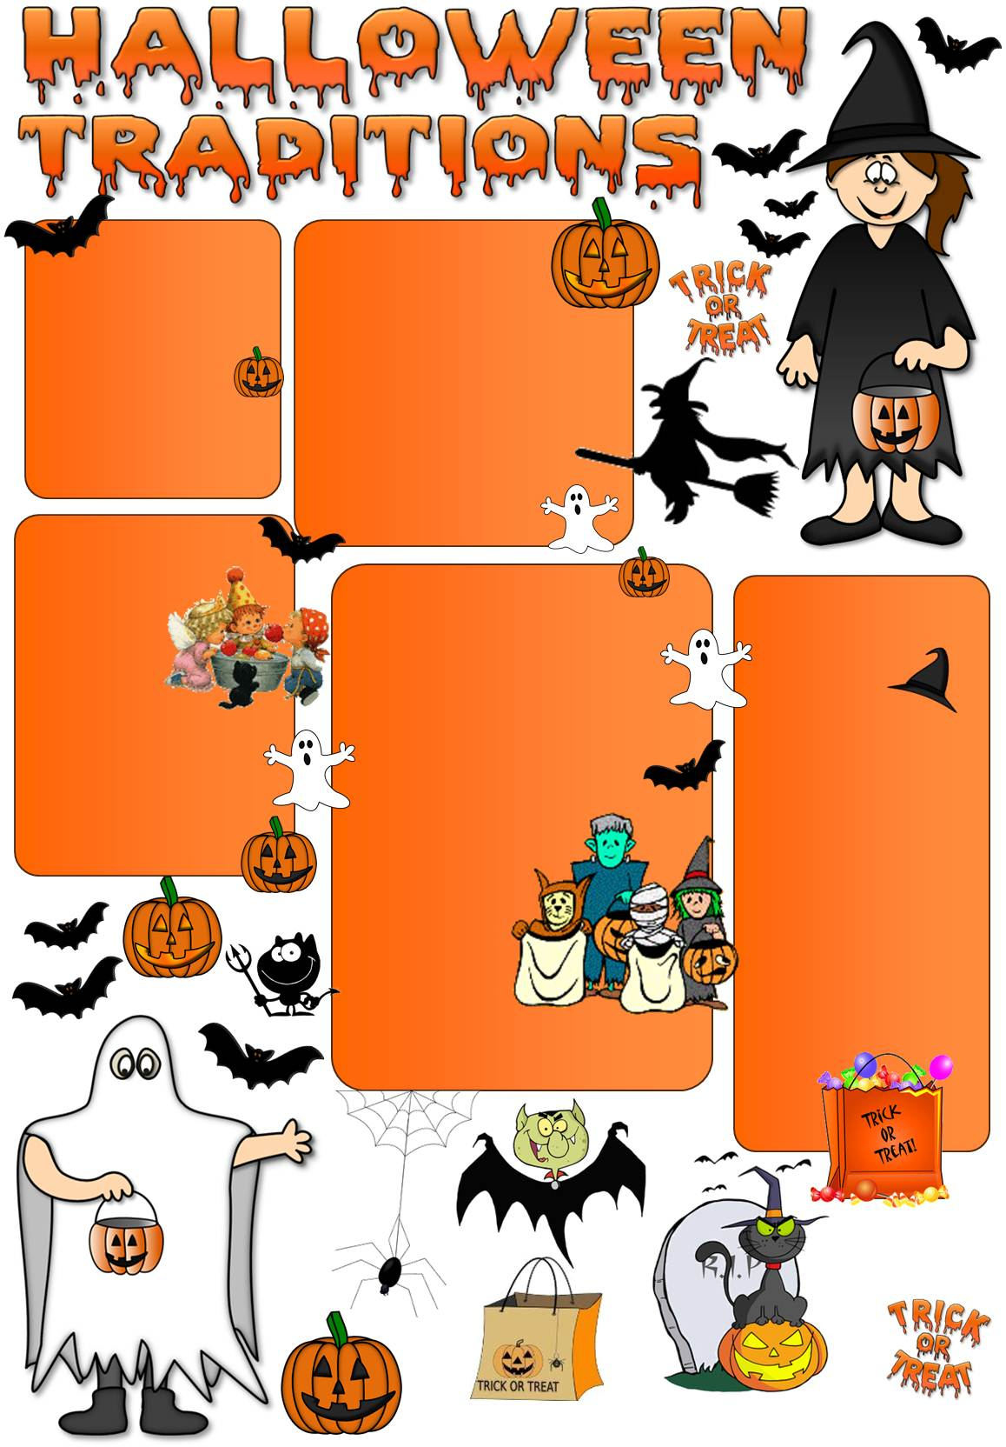
On October 31st, we celebrate Halloween, thought to be the one night of the year when ghosts, witches, and fairies are especially active. So what do people do on Halloween Day in England?

are hollowed out pumpkins
with a face cut in one side
and a candle put inside. In the old days people lit fires to scare away bad spirits. They believed light had power over darkness. Today Jack-o-lanterns are supposed to frighten away ghosts and witches.
Jack-o-lanterns

One Halloween party
game is called
‘bobbing for
apples’. Apples
are put in a big bowl
full of water. The players, sometimes blindfolded must take an apple out of the water without using their hands.

Apple Bobbing

On Halloween, when it was believed that bad spirits came back to the earthly world, people thought they would meet ghosts if they left their homes. To avoid being recognized by ghosts people would wear masks
when they left homes after dark so that the ghosts would
mistake them for fellow
spirits. That’s why
Halloween
costumes are
traditionally
monsters such as
vampires, ghosts, witches and devils.
Dressing up

Children in costumes
go from house to
house in their neighbourhood, often in small groups, in order to ask for treats such as sweets, lollipops, chocolates or money. When someone answers the door, the children say: ’Trick or treat?’ The "trick" is a threat to perform mischief on the homeowners or their property if no treat is given.
Trick or Treat
Texts adapted from: www.projectbritain.com and www.wikipedia.org

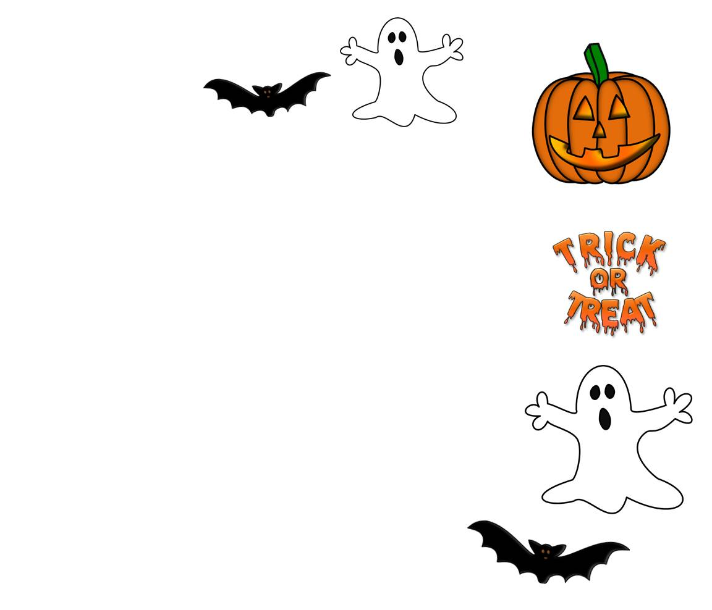
Answer the questions.
When is Halloween celebrated?
_ _ _ _ _ _ _ _ _ _ _ _ _ _ _ _ _ _ _ _ _ _ _ _ _ _ _ _ _ _ _ _ _ _ _ _ _ _ _ _ _
What is put in a bowl full of water?
_ _ _ _ _ _ _ _ _ _ _ _ _ _ _ _ _ _ _ _ _ _ _ _ _ _ _ _ _ _ _ _ _ _ _ _ _ _ _ _ _
What costumes do children usually wear on Halloween?
_ _ _ _ _ _ _ _ _ _ _ _ _ _ _ _ _ _ _ _ _ _ _ _ _ _ _ _ _ _ _ _ _ _ _ _ _ _ _ _ _
Why do people put a candle inside Jack-o-lantern?
_ _ _ _ _ _ _ _ _ _ _ _ _ _ _ _ _ _ _ _ _ _ _ _ _ _ _ _ _ _ _ _ _ _ _ _ _ _ _ _ _
What do children say when they call at people’s door?
_ _ _ _ _ _ _ _ _ _ _ _ _ _ _ _ _ _ _ _ _ _ _ _ _ _ _ _ _ _ _ _ _ _ _ _ _ _ _ _ _
Why did people wear masks when they left houses in the past?
_ _ _ _ _ _ _ _ _ _ _ _ _ _ _ _ _ _ _ _ _ _ _ _ _ _ _ _ _ _ _ _ _ _ _ _ _ _ _ _ _
Is Halloween celebrated in your country?
_ _ _ _ _ _ _ _ _ _ _ _ _ _ _ _ _ _ _ _ _ _ _ _ _ _ _ _ _ _ _ _ _ _ _ _ _ _ _ _ _
What are the traditions and superstitions of Halloween in your country?
_ _ _ _ _ _ _ _ _ _ _ _ _ _ _ _ _ _ _ _ _ _ _ _ _ _ _ _ _ _ _ _ _ _ _ _ _ _ _ _ _
What’s your favourite costume?
_ _ _ _ _ _ _ _ _ _ _ _ _ _ _ _ _ _ _ _ _ _ _ _ _ _ _ _ _ _ _ _ _ _ _ _ _ _ _ _ _
10. Do you go to Halloween parties?
_ _ _ _ _ _ _ _ _ _ _ _ _ _ _ _ _ _ _ _ _ _ _ _ _ _ _ _ _ _ _ _ _ _ _ _ _ _ _ _ _
11. Do you like Halloween? Why?/Why not?
_ _ _ _ _ _ _ _ _ _ _ _ _ _ _ _ _ _ _ _ _ _ _ _ _ _ _ _ _ _ _ _ _ _ _ _ _ _ _ _ _
Exercises

